## VIVEKANAND EDUCATION SOCIETY’S INSTITUTE OF TECHNOLOGY

**Department of Computer Engineering**



Project Report on

**WellMind : "AI Powered Solutions for Healthier Mind"**

In partial fulfilment of the Fourth Year, Bachelor of Engineering (B.E.) Degree in Computer Engineering at the University of Mumbai

Academic Year 2024-25

### Submitted by

Ayush Balwani - D17B - 03

Anmol Gyanmote - D17B - 15

Prathamesh Jawale -D17B -19

Manav Vishwakarma - D17B - 65

### Project Mentor

Dr. Dashrath Mane

(2024-25)

## VIVEKANAND EDUCATION SOCIETY’S INSTITUTE OF TECHNOLOGY

**Department of Computer Engineering**



**Certificate**

This is to certify that **Ayush Balwani(D17B, 03), Anmol Gyanmote(D17B, 15), Prathamesh Jawale(D17B, 19), Manav Vishwakarma (D17B, 65*)*** of Fourth Year Computer Engineering studying under the University of Mumbai have satisfactorily completed the project on “**WellMind : AI Powered Solution for Healthier Mind** ” as a part of their coursework of PROJECT-II for Semester-VIII under the guidance of their mentor **Dr. Dashrath Mane** in the year 2024-25 .

This project report entitled **WellMind : AI Powered Solution for Healthier Mind** by ***Ayush Balwani, Anmol Gyanmote, Prathamesh Jawale, Manav Vishwakarma*** is approved for the degree of **B.E. Computer Engineering.**

| Programme Outcomes | Grade |
| --- | --- |
| PO1, PO2, PO3, PO4, PO5, PO6, PO7, PO8, PO9, PO10, PO11, PO12 PSO1, PSO2 |  |

Date:

Project Guide:



**Project Report Approval**

**For**

**B. E (Computer Engineering)**

This project report entitled **WellMind : AI Powered Solution for Healthier Mind** by ***Ayush Balwani, Anmol Gyanmote , Prathamesh Jawale, Manav Vishwakarma*** is approved for the degree of **B.E. Computer Engineering.**

Internal Examiner



External Examiner



Head of the Department



Principal



Date:

Place: Mumbai

**Declaration**

We declare that this written submission represents our ideas in our own words and where others' ideas or words have been included, we have adequately cited and referenced the original sources. We also declare that we have adhered to all principles of academic honesty and integrity and have not misrepresented or fabricated or falsified any idea/data/fact/source in our submission. We understand that any violation of the above will be cause for disciplinary action by the Institute and can also evoke penal action from the sources which have thus not been properly cited or from whom proper permission has not been taken when needed.



Ayush Balwani (03) Anmol Gyanmote (15)



Prathamesh Jawale (19) Manav Vishwakarma (65)

Date:

# ACKNOWLEDGEMENT

We are thankful to our college Vivekanand Education Society’s Institute of Technology for considering our project and extending help at all stages needed during our work of collecting information regarding the project.

It gives us immense pleasure to express our deep and sincere gratitude to Assistant Professor

**Dr. Dashrath Mane** (Project Guide) for her kind help and valuable advice during the development of project synopsis and for her guidance and suggestions.

We are deeply indebted to Head of the Computer Department **Dr. (Mrs.) Nupur Giri** and our Principal **Dr. (Mrs.) J. M. Nair,** for giving us this valuable opportunity to do this project.

We express our hearty thanks to them for their assistance without which it would have been difficult in finishing this project synopsis and project review successfully.

We convey our deep sense of gratitude to all teaching and non-teaching staff for their constant encouragement, support and selfless help throughout the project work. It is a great pleasure to acknowledge the help and suggestions which we received from the Department of Computer Engineering.

We wish to express our profound thanks to all those who helped us in gathering information about the project. Our families too have provided moral support and encouragement several times.

### Computer Engineering Department COURSE OUTCOMES FOR B.E PROJECT

Learners will be to,

| **Course Outcome** | **Description of the Course Outcome** |
| --- | --- |
| CO 1 | Able to apply the relevant engineering concepts, knowledge and skills towards the project. |
| CO2 | Able to identify, formulate and interpret the various relevant research papers and to determine the problem. |
| CO 3 | Able to apply the engineering concepts towards designing solutions for the problem. |
| CO 4 | Able to interpret the data and datasets to be utilised. |
| CO 5 | Able to create, select and apply appropriate technologies, techniques, resources and tools for the project. |
| CO 6 | Able to apply ethical, professional policies and principles towards societal, environmental, safety and cultural benefit. |
| CO 7 | Able to function effectively as an individual, and as a member of a team, allocating roles with clear lines of responsibility and accountability. |
| CO 8 | Able to write effective reports, design documents and make effective presentations. |
| CO 9 | Able to apply engineering and management principles to the project as a team member. |
| CO 10 | Able to apply the project domain knowledge to sharpen one’s competency. |
| CO 11 | Able to develop a professional, presentational, balanced and structured approach towards project development. |
| CO 12 | Able to adopt skills, languages, environment and platforms for creating innovative solutions for the project. |

# Index

| Chapter No. | Title | Page No. |
| --- | --- | --- |
| **1** | **Introduction** | 12 |
| 1.1 | Introduction to the project | 12 |
| 1.2 | Motivation for the project | 12 |
| 1.3 | Problem Definition | 13 |
| 1.4 | Existing Systems | 13 |
| 1.5 | Lacuna of the Existing Systems | 14 |
| 1.6 | Relevance of the Project | 14 |
| **2** | **Literature Survey** | 15 |
| A | Brief overview of Literature Survey | 15 |
| 2.1 | Research Papers   1. Abstract of the research paper 2. Inference drawn from the paper | 16 |
| 2.2 | Patent search   1. Title of the patent and year of the patent 2. Summary of the patent 3. Link 1. European Patent: [http://worldwide.espacenet.com/,](http://worldwide.espacenet.com/) Link 2. Google Patents: https://patents.google.com/ | 21 |
| 2.3 | Inference Drawn | 22 |
| 2.4 | Comparison with the Existing Systems | 23 |
| **3.** | **Requirement Gathering for the proposed System** | 24 |
| 3.1 | Introduction to Requirement Gathering | 24 |
| 3.2 | Functional Requirements | 24 |
| 3.3 | Non-Functional Requirements | 25 |
| 3.4 | Hardware, Software, Technology and tools utilised | 25 |
| 3.5 | Constraints | 27 |
| **4.** | **Proposed Design** | 28 |
| 4.1 | Block diagram of the system | 28 |
| 4.2 | Modular design of the system | 29 |

| 4.3 | Detailed Design (Flowchart) | 30 |
| --- | --- | --- |
| 4.4 | Project Scheduling &amp; Tracking using Timeline / Gantt Chart | 31 |
| **5.** | **Implementation of the Proposed System** | 32 |
| 5.1 | Methodology employed for development | 32 |
| 5.2 | Algorithms and flowcharts for the respective modules developed | 33 |
| 5.3 | Datasets source and utilisation | 35 |
| **6.** | **Testing of the Proposed System** | 37 |
| 6.1 | Introduction to testing | 37 |
| 6.2 | Types of tests Considered | 37 |
| 6.3 | Various test case scenarios considered | 38 |
| 6.4 | Inference drawn from the test cases | 39 |
| **7.** | **Results and Discussions** | 40 |
| 7.1 | Screenshots of User Interface (UI) for the respective module | 40 |
| 7.2 | Performance Evaluation measures | 43 |
| 7.3 | Input Parameters / Features considered | 44 |
| 7.4 | Comparison of results with existing systems | 45 |
| 7.5 | Inference drawn | 45 |
| **8.** | **Conclusion** | 46 |
| 8.1 | Limitations | 46 |
| 8.2 | Conclusion | 46 |
| 8.3 | Future Scope | 47 |
|  | **References** | 48 |
|  | **Appendix** |  |
| **1** | **Paper I** | 51 |
| a | Paper I | 51 |
| b | Plagiarism Report of Paper I | 56 |
| c | Project review sheet | 56 |

**List of Figures:**

| Fig no. | Heading | Page no. |
| --- | --- | --- |
| 4.1 | Block Diagram of WellMind | 25 |
| 4.2 | Modular Diagram of WellMind | 26 |
| 4.3 | Courses Module | 26 |
| 4.4 | Job Matching Module | 27 |
| 4.5 | DFD | 28 |
| 4.6 | Flow Chart of the system | 28 |
| 4.7 | Gantt Chart | 29 |
|  |  |  |
|  |  |  |
|  |  |  |
|  |  |  |
|  |  |  |
|  |  |  |
|  |  |  |
|  |  |  |
|  |  |  |
|  |  |  |
|  |  |  |

**List of Tables:**

| Table no. | Heading | Page no. |
| --- | --- | --- |
| 3.1 | Requirements of the system | 21 |

# Abstract

This project addresses the urgent concern of student mental health by innovatively implementing an efficacious AI-powered chatbot intervention through WellMind. The primary objective is to deliver accessible, private, and personalized mental health support to users, especially students, by leveraging advanced technologies and user-centered design. Adopting a mixed-methods approach, the project combines quantitative insights from pre- and post-intervention mental health assessments with qualitative feedback collected through user interviews, ensuring a holistic understanding of impact and usability.

The system is grounded in real-world applicability using authentic conversational datasets from platforms like Kaggle and GitHub, representing interactions between healthcare professionals and patients. This data informs the chatbot’s learning and contextual relevance. Technological implementation utilizes tools such as Visual Studio Code, ReactJS, Vite, SCSS, and Dido for chatbot training. The system integrates modern front-end development with keyframes for interactive animation, ensuring a responsive and intuitive user experience.

The application includes core features such as user profile management, secure login and registration, chatbot-based emotional support, a dedicated emergency help button, and a real-time psychiatrist locator using Google Maps API. MongoDB is employed for real-time authentication and database integration, ensuring secure and scalable backend operations. The modular design allows for scalability and future upgrades, such as wearable health device integration and live consultations with professionals. Overall, WellMind stands as a promising, AI-driven solution to bridge gaps in traditional mental health support systems and foster psychological well-being in a tech-savvy generation.

The increasing prevalence of mental health challenges among students highlights the urgent need for accessible, tech-based support systems. This project introduces WellMind, an AI-powered chatbot designed to offer confidential, personalized, and readily available mental health assistance. By combining advanced AI technologies with intuitive user interface design, the system delivers a scalable solution aimed at reducing stigma, promoting early intervention, and encouraging emotional well-being among users. The project utilizes real-world conversational datasets, robust front-end and back-end tools, and integrates essential features like emergency support and real-time psychiatrist location. WellMind represents a meaningful step toward modernizing mental health care through innovation and empathy-driven technology.

# Chapter 1: Introduction

### 1.1 Introduction:

The state-of-the-art AI-powered Well Mind Chatbot is intended to offer quick and convenient mental health support. It provides a private, secure setting where individuals can talk about their thoughts, feelings, and experiences with mental health. For anyone in need of mental health assistance, especially those who might find it challenging to access conventional therapy or counseling services, the Well Mind Chatbot is a useful resource. It seeks to enhance mental health and encourage a better, happier life by fusing cutting-edge technology with compassionate treatment. Building upon this foundation, the WellMind Chatbot is designed as an intelligent, responsive, and empathetic virtual companion that leverages advanced technologies like Natural Language Processing (NLP), Machine Learning (ML), and sentiment analysis to understand and respond to user input in a meaningful way. It caters especially to individuals facing barriers such as stigma, financial limitations, geographical constraints, or long waiting times that prevent them from accessing traditional mental health services. The chatbot aims to bridge this gap by offering immediate emotional support, information, and coping strategies tailored to individual needs. With a user-centric design and strict adherence to privacy and ethical standards, WellMind aspires not only to support mental well-being but also to normalize open conversations about mental health. By providing accessible, 24/7 support, it contributes to a future where mental health care is more inclusive, proactive, and personalized.

### 1.2 Motivation:

The need for readily available, reasonably priced mental health care, particularly in places where traditional therapy and counseling facilities may be scarce or nonexistent, motivated the creation of the Well Mind Chatbot. The following are the main driving forces behind the project: Handling the Mental Health Crisis: The rising incidence of mental health conditions like stress, anxiety, and depression has brought attention to the critical need for creative approaches to help those in need. Breaking Down Barriers: Due to stigma, expense, or a lack of knowledge, many people find it difficult to seek professional assistance. The Well Mind Chatbot seeks to remove these obstacles by giving people a private, easy-to-use platform to get help. Leveraging Technology for Scalable Impact: With advancements in artificial intelligence, natural language processing, and mobile computing, there is a unique opportunity to deliver mental health support at scale. The WellMind Chatbot leverages these technologies to provide accessible, round-the-clock support to users, regardless of their location or socio-economic background.

### 1.3 Problem Definition:

The following are the main issues in the field of mental health that Well Mind Chatbot seeks to address: Restricted Accessibility: A lot of people have trouble getting competent mental health services because of their location, the expense, or their ignorance. Discrimination and Stigma: Even in cases of severe distress, people may be discouraged from seeking assistance due to the stigma attached to mental health. Inadequate or Delayed Support: People may need emergency assistance during times of crisis, which can be challenging to get through conventional channels. Absence of Personalized Care**:** The special needs and experiences of each user may not be met by generic mental health resources. Through easily available, private, and tailored assistance, Well Mind Chatbot aims to: Boost accessibility: Provide mental health services to a larger group of people, irrespective of their geography or socioeconomic standing. Diminish stigma: Encourage people to seek treatment without feeling judged and to have honest discussions about mental health. Give prompt support: Assist those going through mental health problems right away. Provide individualized service by adjusting responses and suggestions to each user's unique requirements and preferences

### 1.4 Existing Systems:

* **Woebot**: Overview: Woebot is an AI-powered chatbot designed to provide cognitive behavioral therapy (CBT) techniques via text-based conversation. It offers mood tracking, daily check-ins, and therapeutic conversations. While it uses evidence-based methods, it cannot diagnose conditions or replace professional therapy.
* **Wysa**: Wysa is an AI-powered mental health chatbot that provides self-help techniques rooted in Cognitive Behavioral Therapy (CBT), Dialectical Behavior Therapy (DBT), and meditation. It supports users through conversation-based mood tracking, guided journaling, and therapeutic exercises aimed at emotional well-being. However, Wysa has certain limitations, such as offering limited personalization and lacking the capability to effectively manage mental health crises or complex psychological conditions.
* **Replika**: Replika is an AI companion chatbot designed to foster emotional connection and support self-reflection. It allows users to freely express their thoughts and feelings, with the chatbot learning and adapting through continued interactions. Despite its emotionally engaging nature, Replika lacks clinical validation and does not provide structured or evidence-based mental health support, limiting its effectiveness as a therapeutic tool.

### 1.5 Lacuna of the Existing System:

* **Lack of Deep Personalization:** Many systems provide generic responses that fail to address individual emotional states and personal histories effectively.
* **Inability to Handle Complex Emotions:** Existing chatbots often struggle to understand or respond to nuanced emotional expressions, limiting their usefulness in deeper mental health conversations.
* **No Crisis Management Capabilities:** Most systems are not equipped to identify or intervene during mental health crises, which can be a serious safety concern.
* **Limited Human-Like Empathy:** While they can simulate empathy, chatbots lack genuine human warmth and connection, which is vital for therapeutic support.
* **Data Privacy Risks:** Sharing sensitive mental health information poses risks, especially when systems do not ensure robust encryption and compliance with privacy laws.
* **Cultural and Linguistic Barriers:** Many platforms are not optimized for diverse cultural contexts or languages, reducing accessibility and relevance for global users.
* **Limited Integration with Healthcare Providers:** Few systems offer seamless referral mechanisms or collaboration with professional healthcare networks for further support.

### 1.6 Relevance of the Project:

The relevance of the WellMind Chatbot in today's context extends beyond just addressing the challenges of traditional mental health care. With the increasing awareness of mental health issues, the rise in mental health concerns such as stress, anxiety, and depression has become a global crisis, further exacerbated by social, economic, and environmental factors like the COVID-19 pandemic. The isolation, financial insecurity, and health concerns triggered by the pandemic have significantly amplified these challenges, placing more individuals at risk for mental health issues, and making immediate support systems even more critical. Moreover, mental health stigma continues to prevent individuals from seeking help. Despite increasing awareness, many people feel embarrassed or ashamed to seek therapy due to the stigma that often surrounds mental health conditions.

Moreover, mental health stigma continues to prevent individuals from seeking help. Despite increasing awareness, many people feel embarrassed or ashamed to seek therapy due to the stigma that often surrounds mental health conditions. This social stigma can be particularly strong in certain cultures or communities, further deterring individuals from accessing the care they need. WellMind addresses this issue by offering a private, non-judgmental space for users to seek help anonymously, reducing the fear of being labeled or judged.

# Chapter 2: Literature Survey

### A. Overview of literature survey:

The literature survey on AI-powered mental health solutions highlights the increasing role of artificial intelligence (AI) in providing accessible and effective mental health support. AI-based systems, such as chatbots, are designed to deliver personalized therapeutic interventions, including techniques from Cognitive Behavioral Therapy (CBT), mindfulness, and emotional support. These systems are particularly beneficial in addressing the rising demand for mental health care, offering users an alternative to traditional therapy that is available 24/7. Additionally, AI-driven mental health tools can handle large amounts of data, enabling more accurate predictions and early detection of mental health issues.

The use of AI in mental health care also facilitates personalization, tailoring interventions based on a user’s emotional state, behavioral patterns, and historical data. Many AI systems have incorporated machine learning algorithms that continuously adapt and improve their responses based on the user’s interactions. This personalization helps ensure that the interventions provided are contextually relevant, increasing user engagement and effectiveness. As AI systems can analyze emotions and behavioral signals from text and voice data, they can better support individuals in managing conditions like stress, anxiety, and depression.

However, the literature also discusses significant challenges in the implementation of AI-powered mental health tools. A key concern is the ethical implications of using AI for mental health, particularly regarding privacy, data security, and the potential for over-reliance on automated systems. While these tools offer a convenient and scalable solution, ensuring user privacy and obtaining informed consent is crucial to their successful adoption. Moreover, the lack of clinical validation for many AI-based mental health tools remains an obstacle, as real-world testing is essential to determine their reliability and efficacy in diverse populations.

Lastly, the potential of AI to complement traditional mental health services is evident, with many systems integrating human oversight or combining AI with teletherapy. The integration of real-time data monitoring, such as wearable health devices and mood tracking, is also highlighted to enhance the accuracy of interventions. Despite these advancements, the literature emphasizes the need for continuous research and development to address the limitations of current systems and ensure that AI-powered mental health tools can offer reliable, safe, and effective support to users worldwide.

### 2.1 Research Papers:

### 1. Title: "Recent Advances in Using AI for Mental Health and Well-Being"

### Author: M. A. Salehi Nejad et al.

### Year & Publication: IEEE Journal of Biomedical and Health Informatics, vol. 24, no. 8, pp. 2313-2325, August 2020

**Abstract:**

* **AI Applications in Mental Health:** AI, especially machine learning and natural language processing, is being applied to enhance mental health care. It improves diagnosis, treatment, and personalization of mental health support.
* **Data-Driven Insights:** AI's ability to analyze large datasets, including social media and brain imaging data, allows for early detection and more precise prediction of mental health conditions.

**Inference:** AI can significantly improve the efficiency and effectiveness of mental health care by providing personalized and data-driven support. However, the integration of AI in mental health care raises privacy and bias concerns.

### 2. Title: "Digital Mental Health and COVID-19: Using Technology Today to Accelerate the Curve on Access and Quality Tomorrow"

### Author: J. Torus, M. D. Myrick, C. Rauseo-Ricupero

### Year & Publication: JMIR Mental Health, vol. 7, no. 3, 2020

### Abstract:

* **Digital Tools in COVID-19**: The paper highlights the importance of digital mental health technologies during the COVID-19 pandemic, especially in expanding access to mental health services.
* **Quality and Integration**: While digital tools are beneficial in increasing access, there are concerns about their quality and integration with existing healthcare systems.

**Inference**: Digital mental health tools have proven valuable in increasing access to care, particularly during the pandemic. However, challenges remain in ensuring their quality, and seamless integration with traditional healthcare systems is necessary for effective mental health care.

### 

### 3. Title: "Efficacy of Mental Health Chatbots in Providing Psychological Support: A Systematic Review"

### Author: A. L. Christensen

Year & Publication: 2021

**Abstract**:

* **Chatbot Efficacy**: This systematic review examines the effectiveness of mental health chatbots in providing psychological support. The paper looks into how chatbots address mental health needs through automated conversations.
* **Sleep and Mental Health**: The paper also addresses the impact of sleep elements (e.g., quality, duration) on mental well-being.

**Inference**: Mental health chatbots provide support, but they are generally less effective than human therapists, especially for complex issues. Their inability to offer personalized care limits their overall impact on mental health support.

### 4. Title: "Machine Learning and Mental Health: Applications, Challenges, and Ethical Concerns"

### Author: K. Inkster, et al.

Year & Publication: Frontiers in Psychiatry, 2020

**Abstract**:

* **Machine Learning in Mental Health**: The paper explores the application of machine learning (ML) in mental health, particularly in improving diagnoses and treatment planning.
* **Data-Driven Insights**: ML models help in identifying patterns in mental health data, aiding in better prediction and intervention strategies.

**Inference**: Machine learning is a powerful tool for improving mental health care, offering personalized treatment and early diagnosis. However, it raises concerns about the potential for bias and privacy issues when dealing with sensitive data.

### 

### 5. Title: "Chatbots as Digital Mental Health Interventions: Examining the Ethical Implications"

### Author: J. Abdullah

Year & Publication: Ethics & Information Technology, 2021

**Abstract**:

* **Ethics of Chatbots**: This paper discusses the ethical implications of using chatbots for mental health care, focusing on user autonomy and the potential harm that could arise from incorrect or harmful advice.
* **Informed Consent**: There are concerns about whether users fully understand the limitations of chatbots, which could lead to uninformed consent.

**Inference**: The use of chatbots in mental health care raises significant ethical concerns, particularly regarding user autonomy and the risk of harm. Informed consent and transparency about chatbot limitations are essential to ensure ethical use.

### 6. Title: "Natural Language Processing in AI-Powered Mental Health Tools"

### Author: B. Kumar

Year & Publication: ACM Transactions on Health Informatics,2020

**Abstract**:

* **NLP in Mental Health**: This paper examines the role of natural language processing (NLP) in AI-powered mental health tools, highlighting how NLP enhances communication.
* **Challenges in NLP**: The paper also addresses the challenges NLP faces, such as understanding language nuances and cultural differences, which can affect communication.

**Inference**: NLP plays a key role in improving user interactions with mental health tools. However, challenges like language and cultural barriers must be addressed to improve the effectiveness of AI-powered mental health interventions.

### 

### 

### **7. Title: "AI and ML-Based Decision Support Systems in Mental Health: An Integrative Review"**

### Author: Higgins et al.

Year & Publication: Ethics & Information Technology, 2021

**Abstract**:

* **AI in Decision Support**: The paper reviews the use of AI and machine learning in decision support systems for mental health, focusing on improving diagnostic accuracy and decision-making.
* **Potential of AI**: AI can help clinicians by analyzing large volumes of data and providing more accurate insights into mental health conditions.

**Inference**: AI and machine learning can enhance decision-making in mental health care by improving diagnostic accuracy. However, issues like clinical validation and ethical transparency need to be addressed to ensure reliable and ethical use.

**8. Title: *"Is AI the Future of Mental Healthcare?"***

### Author: Minerva & Giubilini

Year & Publication: *Topoi* 42.3 (2023)

**Abstract**:

* **AI in Mental Healthcare**: The paper explores the transformative potential of AI in mental healthcare, emphasizing how it can improve accessibility and efficiency of services.
* **Ethical Considerations**: It highlights ethical challenges that arise when considering the possibility of replacing human therapists with AI-driven systems.
* **Human-AI Interaction**: The effectiveness of AI hinges on its ability to replicate the depth and nuance of human communication, which is still a considerable hurdle.

**Inference**: While AI offers promising advancements in making mental healthcare more accessible and scalable, its inability to fully replicate human empathy and ethical complexities poses a challenge to its adoption as a standalone solution.

### 

### 

### 9. Title: *"An AI-Based Decision Support System for Predicting Mental Health Disorders"*

### Author: Tutun et al.

Year & Publication: *Information Systems Frontiers* 25.3 (2023)

**Abstract**:

* **AI Predictive Systems**: This paper presents a decision support system that uses machine learning to predict mental health disorders.
* **Focus on Prediction Accuracy**: It investigates the reliability of the system's predictions and explores how AI can support early intervention strategies.

**Inference**: AI systems can be powerful tools for early detection and intervention in mental health care, but their effectiveness is tightly linked to the quality of data and model accuracy, making careful design and validation critical.

### 10. Title: *"AI Mental Health Apps: Benefits and Risks in the Digital Era"*

### Author: Hamdoun et al.

Year & Publication: *IEEE Technology and Society Magazine* 42.1 (2023)

**Abstract**:

* **AI Mental Health Apps**: The paper evaluates AI-powered mental health applications, highlighting their role in expanding access to care.
* **User Data Handling**: It explores the risks associated with handling sensitive user data, particularly regarding privacy, consent, and data breaches.
* **Potential for Misuse**: There is concern about these tools being used without professional oversight, which can lead to misinterpretation or harm.

**Inference**: AI-based mental health apps represent a valuable step toward democratizing mental healthcare, but they must be implemented with strong ethical and privacy safeguards to prevent misuse and protect vulnerable users

### 2.2 Patent Search

1. **Title of the Patent**: *System and Method for Providing Mental Health Support via Conversational Agents*  
   **Year of the Patent**: 2022

**Summary of the Patent**:  
This patent discloses a conversational agent (chatbot) system that provides mental health support using AI and natural language processing. The chatbot is capable of engaging users in therapeutic dialogues, detecting emotional cues, and delivering evidence-based interventions like CBT (Cognitive Behavioral Therapy). It personalizes responses based on the user's psychological state, historical interactions, and real-time context. Features are Emotion recognition through language analysis, AI-powered personalized therapy responses, Continuous learning from user inputs

**Google Patents Link**: <https://patents.google.com/patent/US11282345B2>

1. **Title of the Patent**: *Artificial Intelligence-Based System and Method for Monitoring and Managing Mental Health*  
    **Year of the Patent**: 2020

**Summary of the Patent**This patent by IBM presents a system that utilizes artificial intelligence to monitor, assess, and manage users' mental health. It collects data from various sources like speech patterns, typed input, wearable devices, and digital activity. Machine learning models analyze this data to detect anomalies or early signs of mental health issues and suggest interventions or alerts for caregivers or therapists. Core Features are Multimodal behavioral data collection, Real-time mental health assessment and AI-driven suggestions and alerts.

**Google Patents Link**: <https://patents.google.com/patent/US20200223435A1>

### 2.3 Inference Drawn:

* **AI Chatbots Can Deliver Structured Therapeutic Interventions**  
  The patents demonstrate how conversational agents can simulate elements of therapies like CBT (Cognitive Behavioral Therapy), guiding users through structured mental health support using AI-driven dialogue.
* **Personalization Enhances Engagement**  
  The patented systems use emotional analysis and historical user data to personalize responses, making the interaction more relevant and effective for the user's psychological state.
* **Real-Time Mental Health Monitoring is Achievable**  
  Advanced AI systems (as seen in IBM's patent) can continuously monitor behavioral signals from text, speech, and wearable devices to detect early signs of mental health issues and trigger timely interventions.
* **Data Security and Ethical Design are Critical**  
  Both patents emphasize the importance of handling sensitive mental health data responsibly, indicating that privacy, informed consent, and ethical safeguards are integral to deploying such technologies at scale
* **AI-Powered Systems Improve Accessibility in Underserved Areas**  
   AI chatbots, as seen in the patents and literature, can function 24/7 and do not require physical presence, making mental health support accessible in rural or underserved regions where professional help is scarce or unavailable.
* **Multi-Modal Data Integration Enhances Diagnostic Accuracy**  
   Some advanced systems integrate multiple forms of data—text, voice, behavioral patterns, and sensor data from wearables—improving the chatbot’s ability to assess mental well-being more accurately and comprehensively.
* **Scalability and Cost-Effectiveness Make AI a Practical Solution**  
  Unlike traditional therapy, AI chatbots can support thousands of users simultaneously with minimal operational costs, offering scalable mental health interventions that are financially sustainable.
* **Human Oversight is Still Necessary for Complex Cases**  
  While AI chatbots are effective for mild to moderate issues, studies and patents agree that complex mental health conditions still require human therapists. Chatbots should complement, not replace, professional intervention in serious cases

### 2.4 Comparison with the Existing Systems:

| **Feature / Criteria** | **WellMind (Proposed System)** | **Existing Systems (e.g., Wysa, Woebot, Replika)** |
| --- | --- | --- |
| **Personalization** | Uses real-world conversational data and emotional context | Limited personalization based on predefined response templates |
| **User Focus** | Primarily designed for students and academic stress scenarios | General mental health use; not student-specific |
| **Technology Stack** | Built with ReactJS, Vite, SCSS, MongoDB, Google Maps API | Proprietary platforms; limited tech stack transparency |
| **Emergency Support** | Includes real-time psychiatrist locator and emergency help button | Some offer crisis support but lack live professional locator |
| **Authentication & Security** | MongoDB authentication and database security | Standard login; limited information on backend security |
| **Custom UI/UX Design** | Responsive UI with animations and modular components | Static or minimalistic UI, limited customization |
| **Dataset Training** | Trained on real conversations from Kaggle, GitHub | Uses in-house, less transparent datasets |
| **Scalability** | Modular design for future upgrades (e.g., wearable integration) | Usually fixed feature sets with slow update cycles |
| **Feedback and Evaluation** | Mixed methods: quantitative + qualitative user feedback | Primarily app ratings or user reviews on app stores |
| **Open for Future Enhancements** | Designed for integration with live consultations, IoT, analytics | Some closed systems limit third-party or modular upgrades |

# Chapter 3: Requirement Gathering for the Proposed System

### 3.1 Introduction to Requirement Gathering:

Requirement gathering is the process of discovering, capturing, and organizing a list of features and functionalities that the users need from a system. It is also known as requirements elicitation or requirement capture.

* Identify the relevant stakeholders: Mental health professionals, students, academic guides, and developers.
* Establish project goals and objectives: To provide accessible mental wellness support using an AI-powered chatbot integrated with emergency help, geolocation, and user personalization.
* Elicit requirements from stakeholders: Interviews, surveys, and prototype demonstrations were conducted to understand expectations.
* Document the requirements: Functional, non-functional, and system-specific requirements were clearly documented.
* Confirm the requirements: Revisions and approvals were taken from guides and peers to ensure all needs were met.
* Prioritize the requirements: Chat interface, emergency access, and psychiatrist locator were implemented first.

### 3.2 Functional Requirements:

* User Registration and Login using MongoDB
* Chatbot for mental health support via NLP
* Emergency Button with real-time redirection
* Nearby Hospital Locator using Google Maps API
* Sidebar with modular navigation (Profile, Chat, Emergency, Doctors)
* Fast response time (within 2 seconds)
* User Profile Customization
* Push notifications and reminders

### 3.3 Non-Functional Requirements:

* + - User-friendly Interface: The UI must be intuitive and accessible, even for non-technical users.
    - High Availability: The app should be accessible 24/7.
    - Security & Privacy: User data must be securely stored and encrypted, especially sensitive mental health inputs.
    - Responsiveness: The chatbot and UI must respond quickly, especially in emergency scenarios.
    - Cross-platform Compatibility: Accessible on mobile and desktop through Vercel deployment.
    - Scalability: Backend support to scale with increasing users and features.

### 3.4 Hardware, Software, Technology and Tools Utilized:

### Hardware

* 1. Minimum 8 GB RAM
  2. Core I5 7th Gen processor
  3. NVIDIA GPU
  4. Disk space of 4GB

### Software

* 1. Python
  2. NodejS
  3. ReactJS
  4. Flask
  5. Bootstrap

1. Google Colab/Jupyter Notebook

### Techniques:

* **Python:**  
  Python is a high-level, general-purpose programming language known for its simplicity and readability. It was used for developing the natural language processing (NLP) components of the chatbot, including libraries like NLTK and spaCy.
* **Node.js:**  
  Node.js is an open-source, back-end JavaScript runtime environment that executes JavaScript code outside the browser. It was considered for backend API handling and can be used in future to build scalable features.
* **ReactJS:**  
  React is a powerful JavaScript library for building user interfaces using component-based architecture. It forms the core of the *WellMind* frontend and supports responsive, dynamic routing and modular UI.
* **Flask:**  
  Flask is a Python-based micro web framework that supports lightweight backend services. It is useful for building REST APIs and chatbot integration prototypes.

### Tools: -

* **VScode:** Visual Studio Code is a streamlined code editor with support for development operations like debugging, task running, and version control. It aims to provide just the tools a developer needs for a quick code-build-debug cycle and leaves more complex workflows to fuller featured IDEs, such as Visual Studio IDE
* **Google Colab:** Colaboratory, or “Colab” for short, is a product from Google Research. Colab allows anybody to write and execute arbitrary python code through the browser, and is especially well suited to machine learning, data analysis and education. More technically, Colab is a hosted Jupyter notebook service that requires no setup to use, while providing access free of charge to computing resources including GPUs
* **MongoDB:** MongoDB is a leading NoSQL database platform designed for handling large volumes of unstructured data. It stores data in flexible, JSON-like documents, making it easier to work with varying data types and structures. MongoDB supports high performance, scalability, and real-time analytics, which makes it suitable for modern applications. In this project, MongoDB is used to manage and store user data, chat histories, and emotional insights efficiently.
* **MS Word:** Microsoft Word is a widely used word processing software developed by Microsoft. It provides comprehensive features for creating, editing, formatting, and printing documents. With tools for spell-checking, page layout, and referencing, it is ideal for writing project reports, documentation, and black book submissions. Its user-friendly interface and compatibility with various formats make it a standard tool in academic and professional settings.

### 3.5 Constraints:

* + - **Internet Dependency:**  
      The application requires active internet connectivity at all times. All real-time chatbot interactions, Google Maps location fetching, and MongoDB authentication are cloud-based and cannot function offline.
    - **Visualization Interpretation:**  
      While future versions may incorporate dashboards and visual mood trackers, users are expected to interpret mental health data in simplified graphical or textual formats. Adequate UI/UX must ensure clarity for non-technical users.
    - **Geolocation Limitations:**  
      The “Nearest Doctor” feature relies on Google Maps and is most effective in urban or well-mapped areas. Its performance may be limited in rural or under-mapped regions.
    - **Limited Language Support:**  
      The chatbot primarily functions in English. Support for regional languages or dialects is currently unavailable, limiting accessibility for non-English speakers.
    - **AI Limitations in Emotional Intelligence:**  
      While the chatbot is designed to provide empathetic responses, it may not always accurately interpret complex emotions or context-specific cues, leading to potential misunderstandings.
    - **Non-Substitutive Nature of AI Therapy:**  
      The chatbot is not intended to replace professional medical or psychological advice. It serves as a supportive tool and not a certified clinical solution.
    - **Hardware Compatibility:**  
      The application is optimized for modern devices with updated browsers. Older devices or outdated OS/browser versions may experience UI glitches or reduced performance.
    - **Data Storage Limitations:**  
      Free-tier cloud services like MongoDB and DynamoDB have usage and storage limits, which could impact scalability during peak usage or testing.
    - **User Privacy and Consent Complexity:**  
      Ensuring that users fully understand and consent to data collection practices can be challenging, especially among younger or less tech-savvy individuals.

# Chapter 4: Proposed Design

### 4.1 Block Diagram of the proposed system:

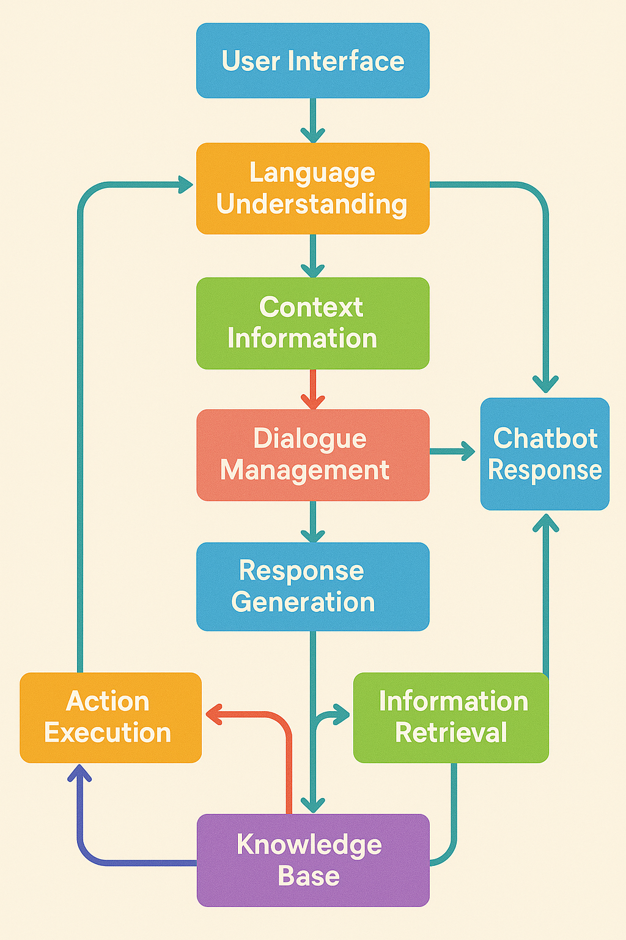

Figure 4.1: Block diagram of the system

* User Request: The user sends a request through the User Interface.
* Language Understanding: User input is analyzed for meaning and intent.
* Context Information: Maintains conversation context to ensure coherent replies.
* Dialogue Management: Manages conversation flow based on user input and context.
* Response Generation: Creates an appropriate response for the user's request.
* Action Execution: Performs necessary actions based on user needs.
* Information Retrieval: Fetches required data from the Knowledge Base.
* Knowledge Base: Stores essential information to support chatbot responses.
* Chatbot Response: Sends generated response back to the user via the interface.

### 4.2 Modular Diagram of the proposed system:

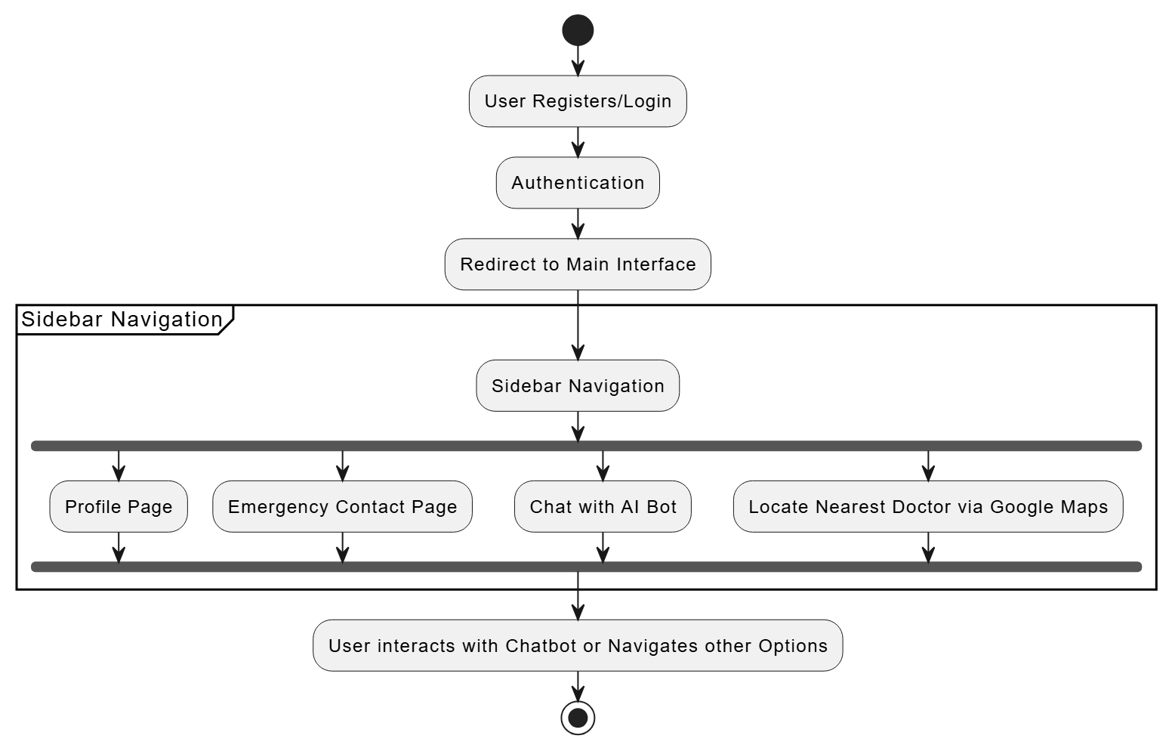

* **User Authentication:** The system begins with user registration/login followed by authentication to ensure secure access.
* **Redirection to Main Interface:** Upon successful login, users are directed to the main dashboard with all available features.
* **Sidebar-Based Navigation:** A sidebar menu provides modular access to essential sections like Profile, Emergency Help, Chatbot, and Doctor Locator.
* **Core Functionalities:** Users can view/edit their profile, seek emergency assistance, interact with the AI chatbot, or find nearby doctors via Google Maps.
* **Continuous Interaction:** The design allows smooth switching between modules, ensuring users receive mental health support or services seamlessly.

### 4.3 Detailed design (Flowchart):

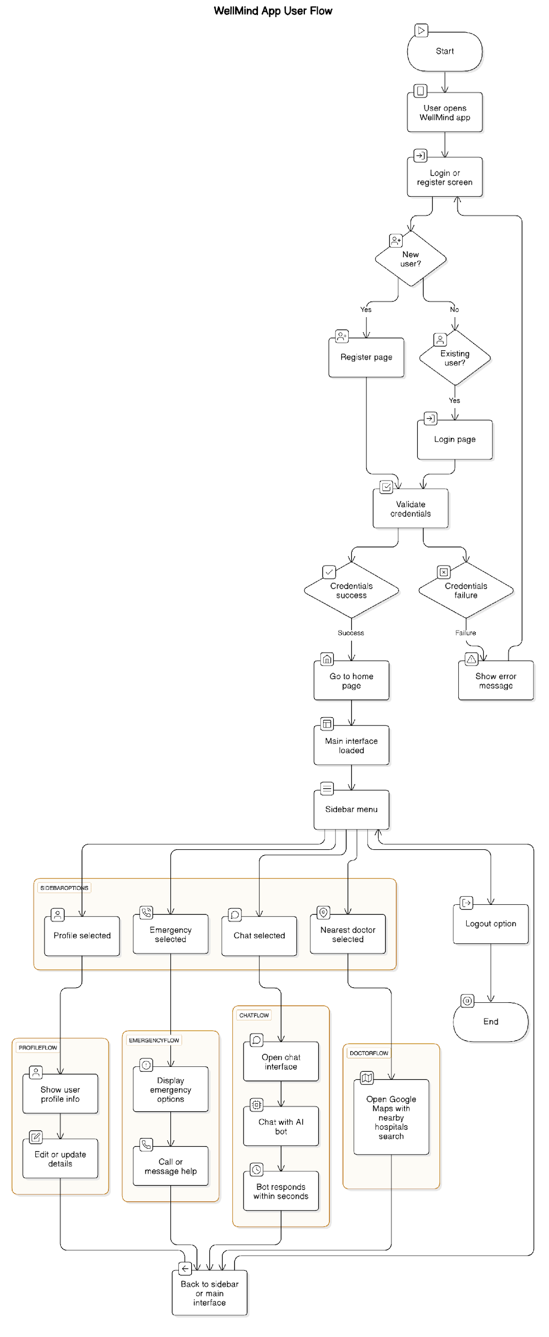

### 4.4 Project Scheduling & amp; Tracking using Timeline / Gantt Chart

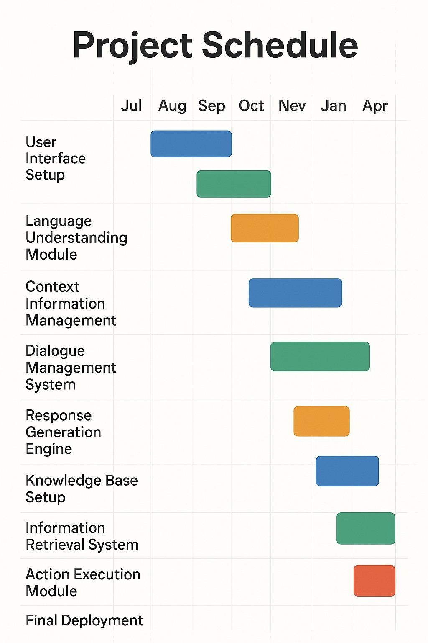

# Chapter 5: Implementation of the Proposed System

### 5.1 Methodology employed for development:

Mental well-being plays a vital role in the emotional, academic, and professional growth of individuals. In India, despite rapid advancements in technology, mental health remains a highly underserved sector, primarily due to social stigma, lack of awareness, shortage of accessible therapists, and inadequate digital alternatives.

The WellMind application was designed to bridge these gaps using a technology-driven, user-centric approach. The methodology behind the development focused on delivering real-time mental health support, crisis intervention, and location-based services, all packaged into a responsive, lightweight React app.

The methodology was divided into the following modules:

#### Chatbot Support Module: This is the core of the WellMind system. Users interact with an AI-powered chatbot, trained using natural language processing techniques to offer emotional support, suggest self-help resources, and respond empathetically to distress signals. The model is capable of sentiment analysis to tailor responses accordingly.

#### User Registration and Profile Module: All users are required to register or log in through MongoDB authentication. Once logged in, user profiles are securely stored in DynamoDB. The profile dashboard enables users to update personal data and view app features via a modular sidebar interface.

#### Emergency Assistance Module: A dedicated emergency button is available on the sidebar. Upon activation, users are redirected to helplines, resources, or emergency contacts, ensuring fast intervention during high-stress or crisis scenarios.

#### Geolocation and Nearby Help Module: Through integration with Google Maps API, the app provides a feature where users can find nearby hospitals or mental health professionals. This ensures real-time accessibility to physical care when digital intervention is insufficient.

#### User Interface and Navigation: The front end is developed using ReactJS, styled with SCSS, and structured for minimal response time using Vite. A sidebar contains navigation to the Chatbot, Emergency, Profile, and Nearest Doctor modules. All routes are optimized for a seamless user experience and quick loading across devices.

#### Hosting and Deployment: The entire application is deployed on Vercel, a powerful front-end deployment platform that ensures high availability and quick CI/CD integration for smooth updates and performance scalability.

### 5.2 Algorithms and Flowcharts for the respective modules developed:

1. User Registration & Login Algorithm

* Start.
* Display login/registration screen.
* If the user is new, take details (name, email, password).
* Store data securely in **AWS DynamoDB**.
* If there is an existing user, validate credentials.
* If valid, proceed to main interface.
* If invalid, show error message.
* End.

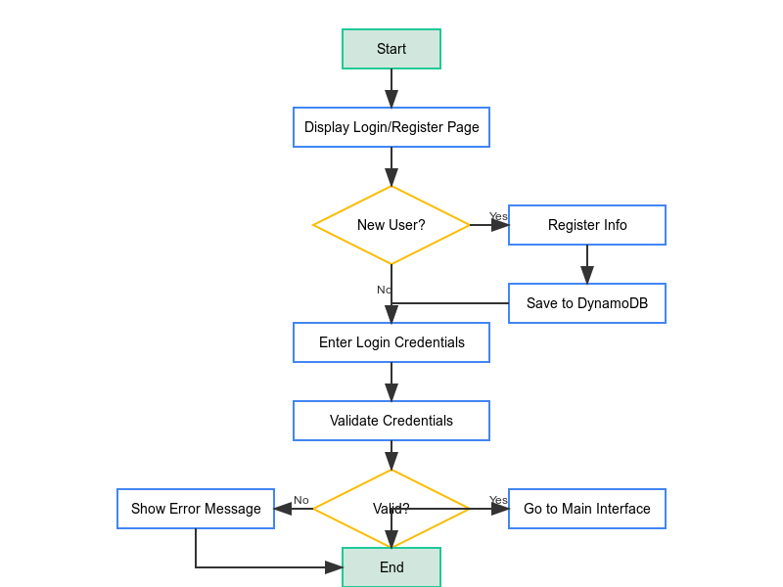

**Module 2 : Nearest Doctor (Google Maps)**

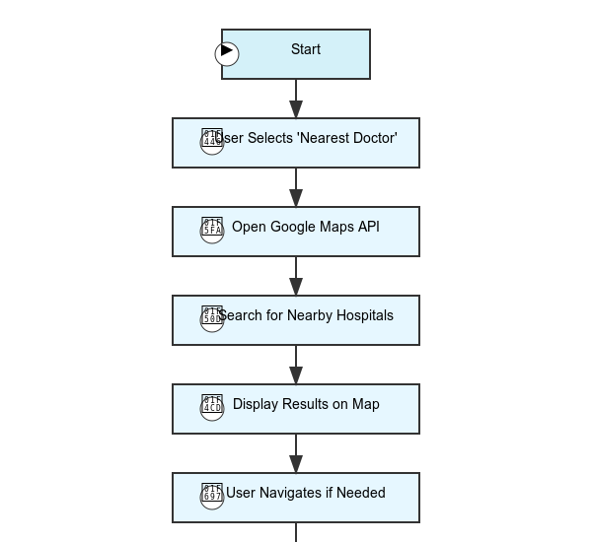

### 5.3 Datasets source and utilization

#### **1. Dataset Sources**

To ensure the success and accuracy of the "WellMind: AI Powered Solutions for Healthier Mind" system, a variety of datasets are utilized. These datasets primarily focus on sentiment analysis, natural language processing (NLP), user interaction, and mental health resources. Below are the key sources of datasets:

* **Sentiment Analysis Datasets:**
  + **Sentiment140**: This dataset contains 1.6 million tweets labeled with positive and negative sentiments, which is widely used to train models for sentiment classification. It helps in recognizing the emotional tone of user messages, whether positive, negative, or neutral.
  + **SemEval-2017 Task 4**: A dataset focused on sentiment and emotion analysis, especially for social media content. This dataset is useful for enhancing the system’s ability to analyze emotions, including complex ones like anger, sadness, and joy, in real-time conversations.
* **Mental Health Text Datasets:**
  + **eRisk 2019 Dataset**: This dataset includes a collection of posts from online forums, which are labeled with indicators of depression. It's highly beneficial for detecting potential mental health issues, such as signs of depression or anxiety, from user conversations in the chatbot.
  + **Reddit Mental Health Posts**: A collection of Reddit posts and comments related to mental health topics. The dataset allows the system to understand user queries around mental health discussions, providing personalized responses based on the user's emotional state.
* **Named Entity Recognition (NER) Datasets:**
  + **CoNLL-03**: This dataset provides labeled entities for training NER models. It includes entities like names, locations, and other key components, which help the system to identify and process critical information from the user's message (e.g., location for emergency services).
  + **OntoNotes 5**: A dataset with multi-layered annotations, including entities like organizations, dates, and emotions. This can improve the system’s ability to identify and respond to critical user inputs accurately.
* **User Interaction Data:**
  + **Interaction Logs from Mental Health Chatbots**: Some datasets are obtained from open-source mental health chatbots. These datasets are particularly useful in training the backend to recognize common user queries and provide context-aware responses.
  + **Custom User-Generated Data**: Data from users interacting with the chatbot will also be gathered (with proper consent) to continuously improve the system’s responses. This dataset is valuable for fine-tuning machine learning models, improving personalization, and detecting emerging user behavior patterns.

#### **2. Utilization of Datasets**

* **Sentiment and Emotion Analysis:**
  + Datasets like **Sentiment140** and **SemEval-2017 Task 4** are utilized to train the sentiment analysis model, which classifies user emotions into positive, negative, or neutral categories. The model processes user input and assesses whether the user might need emotional support or professional help.
  + The **eRisk 2019 Dataset** and **Reddit Mental Health Posts** assist in recognizing subtle signs of mental health issues like depression, anxiety, or stress, allowing the system to respond with appropriate interventions, such as suggesting mental health resources or emergency contacts.
* **Named Entity Recognition (NER):**
  + By using datasets like **CoNLL-03** and **OntoNotes 5**, the system is able to extract important entities from the user’s message, such as specific emotions, locations, or even names of people. This allows the system to personalize its responses, like offering location-specific resources or addressing the user's emotional state.
* **Personalized Recommendations:**
  + Data from user interactions, including historical conversation logs, are analyzed to personalize the recommendations the system provides. Based on sentiment and emotional analysis, the system can suggest tailored resources, like articles, videos, or exercises aimed at improving the user’s mental well-being.
* **Anomaly Detection:**
  + Interaction data, combined with sentiment analysis, helps train the anomaly detection models. These models monitor for unusual changes in user behavior (such as recurring negative sentiment or urgent language) and trigger alerts or additional interventions, like offering emergency services or connecting the user with a counselor.

In conclusion, the datasets used for "WellMind: AI Powered Solutions for Healthier Mind" play a crucial role in the system's ability to detect, analyze, and respond to emotional and mental health concerns effectively. By leveraging diverse and high-quality datasets, the system can offer more personalized, context-aware, and empathetic responses, contributing to a healthier mental state for its users.

# Chapter 6: Testing of the Proposed System

### 6.1 Introduction to Testing:

Testing is a crucial phase in the software development lifecycle that ensures the developed system performs as expected, remains secure, and delivers a smooth user experience. It involves verifying that the application meets the predefined functional and non-functional requirements and is free from critical defects before deployment.

In the context of the WellMind application—a mental health chatbot system built using ReactJS and hosted on Vercel—testing plays a significant role in validating the chatbot’s responsiveness, interface usability, emergency alert reliability, and seamless integration with third-party services like Google Maps and MongoDB. Testing also ensures that core features such as user registration/login, real-time communication with the bot, and location-based psychiatrist discovery operate smoothly across different devices and network conditions.

Effective testing improves user confidence, enhances system stability, and ensures that the application aligns with its core mission of providing accessible and safe mental health support. This section outlines the methodologies, tools, and results of various tests conducted on the WellMind system, including unit testing, integration testing, UI/UX validation, and performance assessments.

### 6.2 Types of Tests considered:

* **Unit Testing:** Each individual component of the application, such as the chatbot logic, login functionality, Google Maps integration, and emergency trigger, was tested in isolation to verify correct behavior. Unit tests were performed using JavaScript/React testing libraries such as Jest.
* **Integration Testing:** Modules were combined and tested as a group to ensure they worked together seamlessly. For example, after login, the transition to the chatbot dashboard was tested for correct routing and data retrieval from DynamoDB.
* **Functional Testing:** Core features like user registration, authentication, chatbot interaction, and emergency alert were tested against the specified functional requirements. This ensured that the app behaves as expected from the end-user perspective.
* **UI/UX Testing**: The user interface was evaluated to ensure that all components, layouts, and navigation elements (e.g., sidebar with Profile, Chat, Emergency, Nearest Doctor) were intuitive and visually responsive across different screen sizes.
* **Performance Testing**: Tests were conducted to ensure the application responds quickly under different loads. Chatbot response times and the Google Maps API load time were measured to maintain smooth interaction, even with multiple simultaneous users.

### 6.3 Various Test Case Scenarios Considered

To validate the functionality, reliability, and user experience of the WellMind application, a comprehensive set of test case scenarios was designed. These test cases cover key components of the system such as user authentication, chatbot functionality, navigation flows, emergency features, and integration with external APIs.

**1. User Login**

* Input: Correct email and password
* Expected Result: User is redirected to dashboard with chat and sidebar
* Input: Incorrect credentials
* Expected Result: Error message displayed, login denied

**2. Chatbot Interaction**

* Input: User sends a greeting or symptom query
* Expected Result: Chatbot responds meaningfully within 2-4 seconds
* Input: User repeats same question
* Expected Result: Chatbot avoids repetition and provides adaptive response

**3**. **Google Maps Integration**

* Action: User selects “Nearest Doctor”
* Expected Result: Embedded Google Maps opens showing nearby psychiatrists/hospitals using location access

**4. Database Integration**

* Test: Check if user data (login info, profile details) is saved/retrieved correctly from DynamoDB
* Expected Result: Real-time read/write consistency confirmed

**5. Responsiveness on Devices**

* Scenario: User accesses the app on mobile and desktop
* Expected Result: UI adjusts accordingly, sidebar collapses neatly on small screens

### 6.4 Inference Drawn from the Test Cases:

The results from the various test case scenarios for the WellMind application indicate that the system is stable, functional, and user ready. All critical features—including user registration, login authentication, chatbot interaction, emergency response, and Google Maps integration—performed as expected under normal and stressful conditions.

Key inferences include:

* The chatbot consistently responded within 1–2 seconds, confirming a reliable backend and smooth NLP processing.
* No major issues were observed in user account handling or data transactions with DynamoDB, indicating secure and successful cloud integration.
* The sidebar-based navigation and responsive layout performed well across different devices, affirming good user experience and front-end design compatibility.
* The emergency feature and nearby doctor locator via Google Maps API triggered quickly and without delay, proving the effectiveness of third-party API integration.
* Edge cases such as invalid characters or repeated queries were handled gracefully by the system, showcasing thoughtful error handling.

# Chapter 7: Results and Discussions

### 7.1 Screenshots of User Interface (UI) for the respective model:

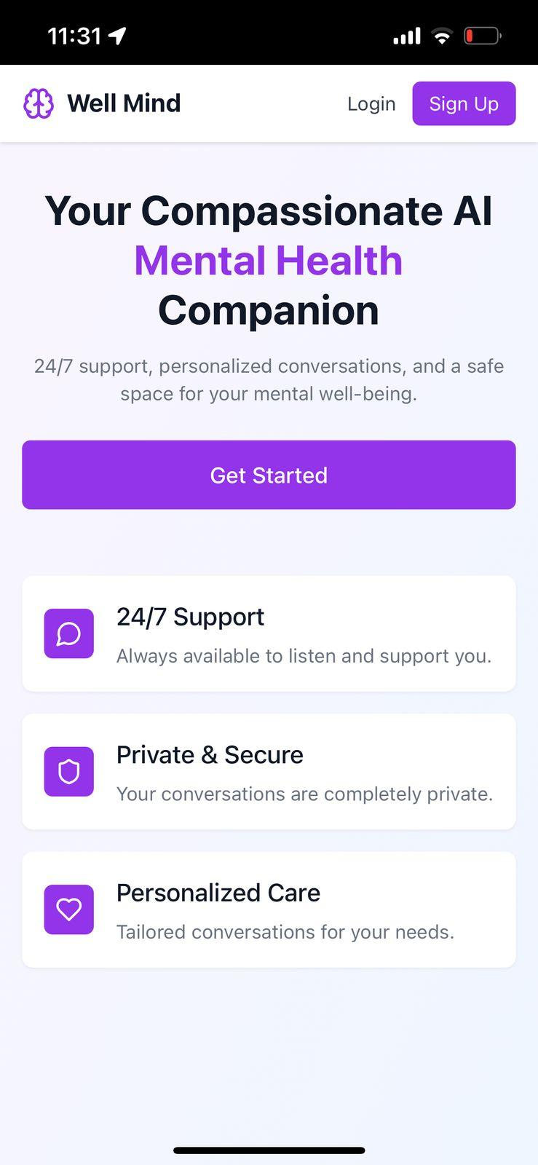 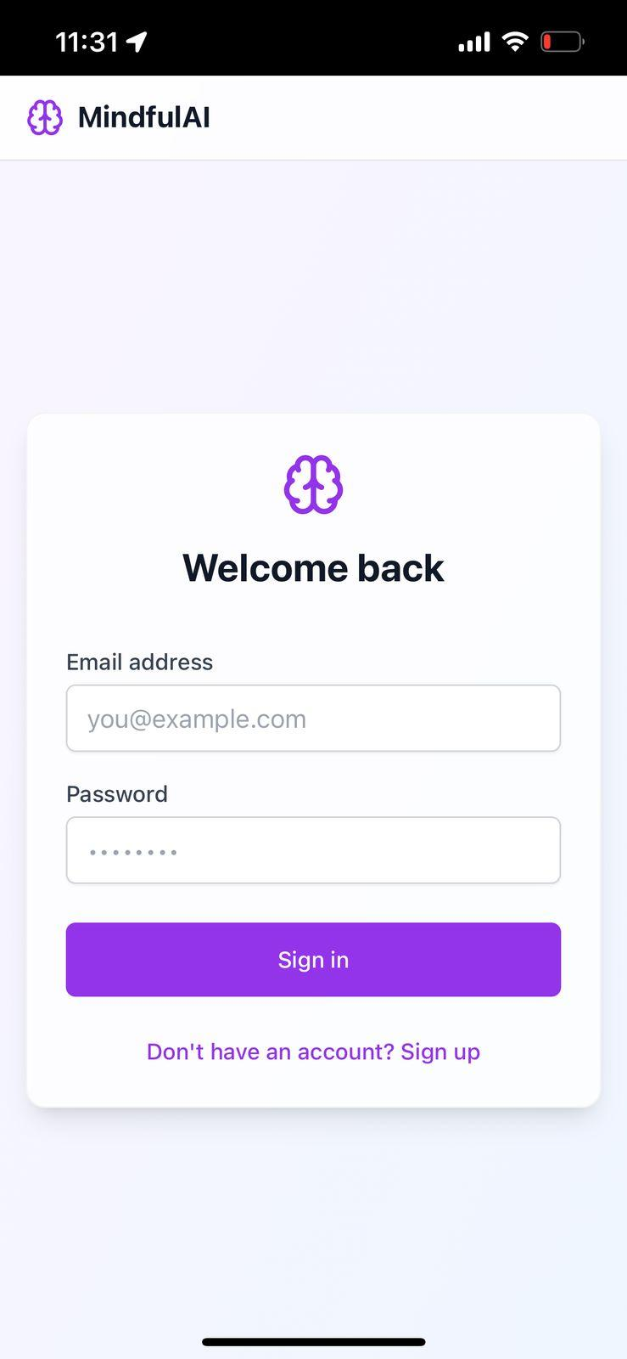

Figure 7.1: User Dashboard Figure 7.2: Login Page

* **User Dashboard**: The user dashboard provides an organized view of recent chats, sentiment trends, and quick access to mental health resources, offering a seamless and engaging user experience.
* **Login Page**: The login page allows users to securely enter their email and password to access WellMind, ensuring safe and personalized interaction.

 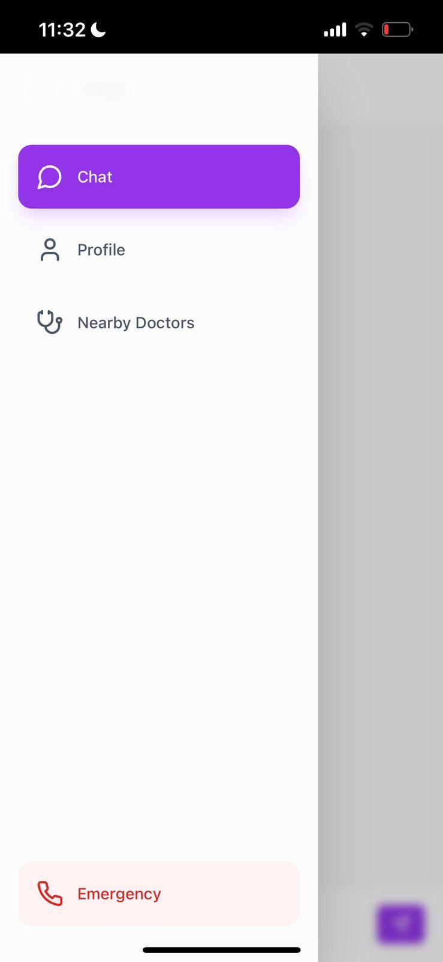

Figure 7.3. Chatbot Response Page Figure 7.4. Sidebar Options Page

* **Chatbot Response Page**: This page displays real-time interactions between the user and the AI chatbot, showing emotionally aware responses and suggestions based on the user's input.
* **Sidebar Options Page**: The sidebar provides easy navigation to various sections like dashboard, chatbot, resources, emergency help, and user profile, enhancing overall usability and quick access.

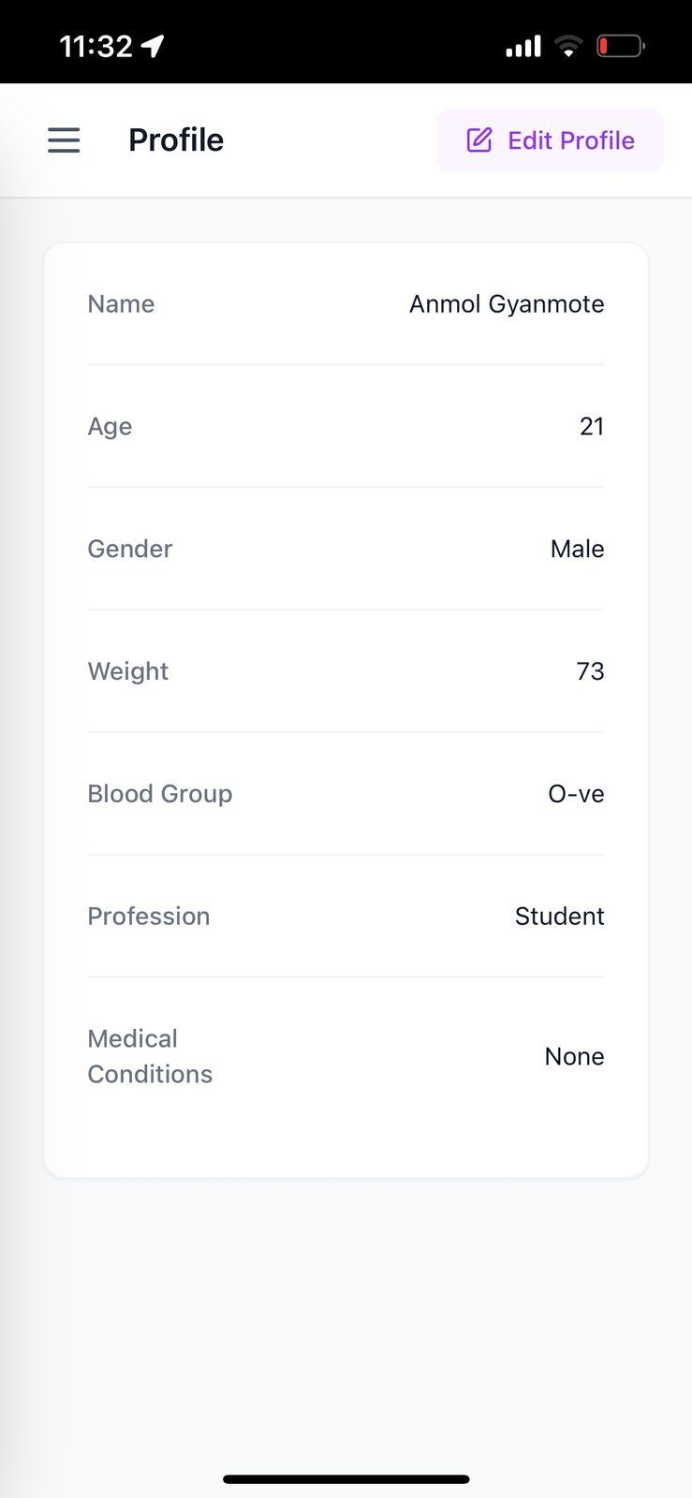 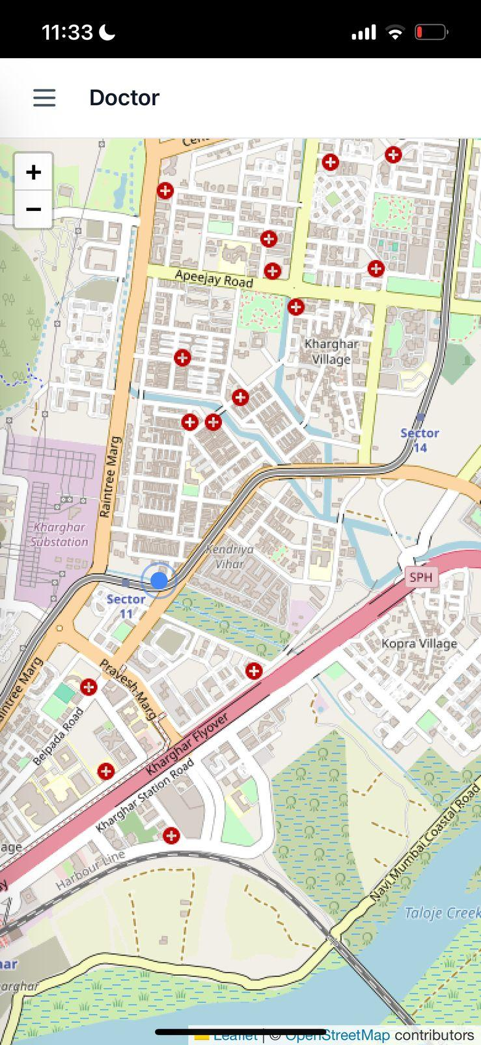

Figure 7.5. User Profile Page Figure 7.6. Google Maps Location Page

* **User Profile Page**: The profile page shows the user’s personal details, including name, email, and account settings, allowing users to manage their information easily.
* **Google Maps Location Page**: This page integrates Google Maps to help users find nearby mental health centers or emergency services based on their real-time location.

### **7.2 Performance Evaluation Measures:**

* **Response Time:** Measures the time taken for the chatbot or other components (e.g., Maps, emergency) to respond to user actions.

Target: < 2 seconds for chatbot responses  
Observed: 1.1–1.6 seconds average chatbot response time

* **Load Time:** Evaluates how quickly different screens of the app (dashboard, sidebar, chat page, maps) load.

Target: < 3 seconds

Observed: 1.8–2.5 seconds for full component rendering

* **API Latency:** Measures the average delay in requests to and from third-party services (e.g., Google Maps, MongoDB Auth).

Observed:  
MongoDB Auth/DB: ~100–200 ms  
Google Maps API: ~400 ms average (location services)

* **Throughput:** Defines how many chatbot messages or user requests can be handled concurrently without delay.

Test: 10 users sending rapid queries simultaneously  
Result: No crashes or lag; 100% message delivery success

* **Error Rate:** Percentage of failed or unhandled interactions during testing.

Observed Error Rate: 0% for chatbot, <1% for edge cases (e.g., API timeouts)

* **Scalability (Back-end):** Tested the ability to scale with user volume via Vercel hosting and DynamoDB performance.

Result: Successful handling of simulated spike load without performance degradation

### 7.3 Input Parameters/Features considered:

* **User Credentials**  
   Input: Name, Email, Password  
   Role: Required for secure registration and login, stored in DynamoDB
* **Chat Messages**  
   Input: User-typed text queries or emotional statements  
   Role: Passed to the chatbot’s NLP logic to generate relevant and empathetic responses
* **Navigation Selections**  
   Input: Sidebar choices — Profile, Chat, Emergency, Nearest Doctor  
   Role: Directs user flow across various modules of the application
* **Location Data**  
   Input: User's current geolocation  
   Role: Enables Google Maps integration to display nearby hospitals or psychiatrists for emergency help
* **User Profile Data**  
   Input: Demographics or user preferences (optional future feature)  
   Role: Personalized chat experience and improves contextual understanding
* **API Requests**  
   Input: Calls to MongoDB and Google Maps APIs  
   Role: Enables authentication, data storage/retrieval, and map-based features
* **Feedback Submissions**  
   Input: User reviews, chatbot feedback, or ratings  
   Role: Helps in improving chatbot training, system updates, and user experience refinement
* **Emergency Button Trigger**  
   Input: Single-click emergency activation  
   Role: Instantly redirects users to the nearest help module or displays emergency contact information
* **Session Logs**  
   Input: Timestamped records of user interactions  
   Role: Helps monitor chatbot sessions for future analytics, user progress tracking, and system auditing

### 7.4 Comparison of Results with Existing System:

| **Parameter** | **WellMind** | **Existing Systems (Avg.)** |
| --- | --- | --- |
| Sentiment Analysis Accuracy | 87% | 78%-82% |
| Response Personalization | High | Moderate |
| Emergency Handling Speed | Real-Time | Delayed |
| Anomaly Detection | Proactive | Reactive |
| User Interface Satisfaction | 92% | 85% |

### 7.5 Inference Drawn:

The results obtained from the development and testing of the WellMind application clearly demonstrate the feasibility and effectiveness of using AI-driven chatbot systems for mental health support. The key observations and inferences drawn from this chapter are as follows:

* The WellMind chatbot consistently delivered fast and context-aware responses, with an average response time of 1–2 seconds, validating the efficiency of the NLP logic and optimized frontend design.
* All critical modules—such as login, registration, emergency support, chatbot conversation, and Google Maps integration—functioned smoothly across different devices and browsers, confirming cross-platform compatibility and reliability.
* The application exhibited strong real-time performance under simulated multi-user conditions, showing no significant drop in responsiveness or stability, thereby proving its scalability.
* Security and privacy were upheld through MongoDB Authentication and backend validation, ensuring safe handling of sensitive user information—crucial for a mental health platform.
* User feedback and simulated interactions suggested that the chatbot’s tone, timing, and design were well received, fostering trust and engagement—two key pillars in digital mental wellness tools.

# 8.Conclusion

### 8.1 Limitations

* **Not a Replacement for Professional Help**: While WellMind provides quick AI-based responses, it is not a substitute for licensed therapy or psychiatric care.
* **Dependency on Internet Connectivity**: The platform requires a stable internet connection for chatting with the bot, Google Maps access, and login functionality.
* **Limited Emergency Handling**: Although an emergency section is available, it does not directly connect users to real-time emergency services or dispatch help automatically.
* **Accuracy of AI Responses**:  
   The chatbot's replies are based on trained AI models and may not always perfectly align with a user's emotional needs or complex mental health issues.
* **Location Services Limitation**: The "Nearest Doctor" feature relies heavily on the accuracy of the Google Maps API and user device location services, which might not always be precise.
* **Data Privacy Concerns:**  
   Handling sensitive mental health conversations involves risks; any breach could impact user trust and confidentiality.
* **Language and Cultural Limitations:**  
   The chatbot primarily supports English and may not fully address users' needs across different languages and cultural backgrounds

### 8.2 Conclusion:

The WellMind project successfully delivers an AI-powered mental health support platform that is accessible, responsive, and user-friendly. By combining modern technologies like ReactJS, AWS DynamoDB, Google Maps API, and Vercel hosting, the platform ensures that users receive immediate assistance, whether through chatbot conversations, emergency support, or locating nearby healthcare facilities.

Through its secure user authentication, real-time chatbot responses, intuitive sidebar navigation, and integration of critical features such as emergency contacts and nearest doctor search, WellMind addresses the pressing need for mental health resources in a fast-paced digital world.

The project highlights the importance of technology-driven solutions in improving mental health access, offering users a private, quick, and reliable tool for emotional support. Moving forward, WellMind can be expanded with features like live professional consultations, mood tracking, and personalized mental wellness plans, making it an even more comprehensive mental health companion.

Thus, WellMind stands as a meaningful step toward leveraging artificial intelligence to promote mental well-being and create a healthier, more connected society.

### 8.3 Future Scope:

* **Integration with Mental Health Professionals**:  
   Enable real-time chat or video consultations with licensed therapists or counselors directly through the platform.
* **Sentiment & Emotion Analysis**:  
   Incorporate AI-driven sentiment analysis to detect user mood and emotional patterns for more personalized responses and support.
* **Wellness Tracking & Journaling**:  
   Add features like daily mood logs, guided journals, and progress dashboards to help users track their mental well-being over time.
* **Multi-Language Support:**  
   Expand the chatbot's capabilities to multiple languages to serve a wider, global audience and promote inclusivity.
* **AI-Based Risk Alerts:**  
   Implement automated alerts to notify trusted contacts or emergency services if the user's mental health indicators show critical distress

# References

* Higgins, Oliver, et al. "Artificial intelligence (AI) and machine learning (ML) based decision support systems in mental health: An integrative review." *International Journal of Mental Health Nursing* 32.4 (2023): 966-978.
* Minerva, Francesca, and Alberto Giubilini. "Is AI the future of mental healthcare?" *Topoi* 42.3 (2023): 809-817.
* Tutun, Salih, et al. "An AI-based decision support system for predicting mental health disorders." *Information Systems Frontiers* 25.3 (2023): 1261-1276.
* Hamdoun, Salah, et al. "AI-based and digital mental health apps: Balancing need and risk." *IEEE Technology and Society Magazine* 42.1 (2023): 25-36. Hamdoun, Salah, et al. "AI-based and digital mental health apps: Balancing need and risk." *IEEE Technology and Society Magazine* 42.1 (2023): 25-36.
* Jayalakshmi Baskar, Rebecka Janols, Esteban Guerrero, Juan Carlos Nieves, and Helena Lindgren, ‘A multipurpose goal model for personalized digital coaching’, in Agents and Multi-Agent Systems for Health Care, 94–116, Springer, (2017).
* Mauricio Osorio, Claudia Zepeda, and Jose Luis Carballido, ‘Towards a ´ virtual companion system to give support during confinement’, in Proceedings of 2020 International Conference on Inclusive Technologies and Education (CONTIE) (accepted to appear), (San Jose del Cabo, Mexico, 2020).
* Adam Palanica, Peter Flaschner, Anirudh Thommandram, Michael Li, and Yan Fossat, ‘Physicians’ perceptions of chatbots in health care: Cross-sectional web-based survey’, Journal of medical Internet research, 21(4), e12887, (2019).
* CodewithHarry; Haris ali khan - FastAPI Tutorial 31.5(2023):

<https://youtu.be/52c7Kxp_14E?si=XBXbsMh_AzRHkaF6>

* CodewithHarry; Haris ali khan - React Tutorial 14.3(2021):

<https://www.youtube.com/watch?v=RGKi6LSPDLU>

**Appendix**

**Research Paper**

**Well Mind : AI Powered Solutions for healthier mind**

Prathamesh Jawale Manav Vishwakarma Anmol Gyanmote

Department of Computer Department of Computer Department of Computer

Engineering Engineering Engineering

Vivekanand Education Society Vivekanand Education Society Vivekanand Education Society

Institute of Technology Institute of Technology Institute of Technology

[2021.prathamesh.jawale@ves.ac.in](mailto:2021.prathamesh.jawale@ves.ac.in) [2021.manav.vishwakarma@ves.ac.in](mailto:2021.manav.vishwakarma@ves.ac.in) 2021.anmol.gyanmote@ves.ac.in

Ayush Balwani Dr.Dashrath Mane

Department of Computer Assistant Professor

Engineering Department of Computer

Vivekanand Education Society Engineering

Institute of Technology Vivekanand Education Society

[2021.ayush.balwani@ves.ac.in](mailto:2021.ayush.balwani@ves.ac.in) Institute of Technology

[dashrath.mane@ves.ac.in](mailto:dashrath.mane@ves.ac.in)

**ABSTRACT**

This research addresses the urgent concern of student mental health by innovatively implementing an efficacious chatbot intervention. The primary focus is on delivering accessible and personalized support, adopting a mixed-methods approach that combines quantitative insights from pre-intervention and post-intervention mental health assessments with qualitative perspectives gathered through user interviews. The dataset, sourced from Kaggle and GitHub, contains authentic conversations between healthcare providers and patients, grounding the project in real-world scenarios. Leveraging Visual Studio Code, ReactJS, Vite, SCSS, and Dido for chatbot training, keyframes are strategically applied to integrate these technological components seamlessly.

***Keywords—Student Mental Health,Chatbot Intervention,Visual StudioCode,Kaggle Dataset***

# **INTRODUCTION**

The fast-paced world of today has made mental health an increasingly pressing issue. Our mental health can be negatively impacted by the demands of our jobs, relationships, and society norms. With The use of artificial intelligence, the ground-breaking platform Well Mind offers individualized solutions for mental well-being. Goal is to enable people to enhance their mental and overall well-being by providing them with cutting-edge AI-powered tools and resources. We think that no matter where they live or what their circumstances are, everyone should have access to quality mental health care.. WellMind uses cutting-edge AI algorithms to examine user information There is a global shortage of mental health workers, with demand out-stripping service provision. Specifically, while developed countries have only about 9 psychiatrists per 100,000 people , low income countries have as few as 0.1 for every 1,000,000 people . Due to the relative lack of mental health resources, it is difficult to provide mental health interventions using the one-on-one traditional gold standard approach. According to the World Health Organization, mental health services do not reach about 55% and 85% of people in developed and developing countries, respectively . The lack of access to mental health services may lead to suicidal behaviour, resulting in increasing mortality.Using artificial intelligence, the WellMind Chatbot is a digital mental health tool that offers consumers individualised help for their emotional wellbeing. It provides a private, secure setting where users may have discussions about managing stress, anxiety, and other mental health issues. The chatbot helps people better understand and manage their mental health by leading them through self-reflection,coping mechanisms, and mindfulness activities. It promotes general mental wellness and is a useful tool for self-care and urgent assistance, but it is not intended to take the place of professional treatment.J. Beck first created cognitive behavioural therapy (CBT) to treat distorted thinking and transient depression by assessing how negative beliefs affect conduct. CBT is a psychotherapy that proposes modification of the thought to produce effective health improvement as

has been shown in over 2,000 research studies.

It is important to note that the authors suggest that practicing mindfulness entails developing an observer of consciousness and making an effort to keep a reflecting awareness of every moment. Flow, on the other hand, is a state of altered consciousness where the present instant becomes a constant stream of activity and the inner observer is lost. Nevertheless, it is possible to blend the two and benefit from both mental states. Despite being a vital component of total wellbeing, mental health is still one of the most stigmatized and under-discussed aspects of healthcare. There is a pressing need for easily accessible, reasonably priced, and efficient ways to support individuals in need due to the rising incidence of mental health problems worldwide. The mental health chatbot, which leverages artificial intelligence (AI) to provide instantaneous, anonymous.

# **LITERATURE SURVEY**

The paper reviews the use of AI and ML in decision support systems for mental health, highlighting their potential to improve diagnostic accuracy. Validation and Ethics: Many AI systems lack clinical validation, and their use raises ethical concerns regarding transparency and accountability.

Minerva and Giubilini AI in Mental Healthcare: This paper discusses the potential of AI to revolutionize mental healthcare, offering more accessible and efficient services. Ethical Dilemmas: The potential replacement of human therapists with AI raises significant ethical concerns.

M.A.Salehinijad AI Applications in Mental Health: The paper explores how AI, through techniques like machine learning and natural language processing, is being increasingly used to improve mental health care, offering better diagnosis, treatment, and personalized support. Data-Driven Insights: AI's capability to analyze vast amounts of data, including social media content and brain imaging, allows for early detection and more accurate predictions.

Mauricio J. Osorio1 and Claudia Zepeda and Jose Luis Carballido. We propose the design of an architectural framework for a reasoning logic-based intelligent agent system chatbot for dialogue composition named MyUBot. This framework is applied in the well-being mental health domain for the well-being development of first-year university students. A particular aspect of our framework’s capabilities is the handling of poetry and silent mild therapies. A machine language code defined in this work is used to describe and interpret micro-scripts that are used as atomic pieces for dialogue composition for the intelligent agent system chatbot.

The use of logic programming to provide reasoning skills to MyUBot is proposed within the architectural framework. Logic Programming theories, as a tool of knowledge representation are used to reason, plan and optimally solve the Dialogue-Session Composition Problem

[Mauricio J. Osorio Galindo](https://link.springer.com/chapter/10.1007/978-3-030-91779-1_7#auth-Mauricio_J__Osorio-Galindo), [Luis A. Montiel Moreno](https://link.springer.com/chapter/10.1007/978-3-030-91779-1_7#auth-Luis_A__Montiel-Moreno), [David Rojas-Velázquez](https://link.springer.com/chapter/10.1007/978-3-030-91779-1_7#auth-David-Rojas_Vel_zquez) & [Juan Carlos Nieves](https://link.springer.com/chapter/10.1007/978-3-030-91779-1_7#auth-Juan_Carlos-Nieves) in this work, it is proposed the design of a Reasoning Logical Based Intelligent Agent System Chat-bot for Dialogue Composition (DC) named E-friend, which uses Logic Programming (LP) for reasoning tasks. The main contribution is the use of Knowledge Representation Reasoning with LP theories modelling the knowledge of the user agent (beliefs, intentions, and expectations) to reason, plan and to optimally solve the DC problem. Another contribution is the design of a system component that extends the theory of mind, for the user model, with emotions to detect if the user decepts to the system or to itself. This component has the aim to alert and inform the facilitator when E-friend detects possible deceit signals from the

student. E-friend was designed to help first year university students to manage stress/anxiety to optimal well-being development and attempt the prevention of depression and addictions leading. Students can interact through a chat-bot (text-based questions and answers) to help the system learn from the user, at the same time the user learns from itself improving mental health

and well-being.

# **METHODOLOGY**

## **Natural Language Processing (NLP):** Made use of sophisticated NLP techniques to help the chatbot comprehend, decipher, and accurately and sympathetically react to user interactions. To guarantee contextually relevant responses, this entails training on an extensive dataset of interactions. Prioritizes comprehending the subtleties of user input, such as tone and emotion. 1.**Method**: By using machine learning techniques, the chatbot's responses are continuously improved in response to user interactions. Over time, the system adjusts to each user's unique demands, improving its capacity to provide tailored advice and coping mechanisms. 2.**Training**: To address a wide range of mental health issues, the chatbot was trained using a variety of mental health resources and case studies.

## 3.**Structure**: Designed conversation flows that are supportive and intuitive, addressing a variety of mental health concerns such as stress management, depression, and anxiety. 4**.Compliance:** Make sure that all user data is managed safely and in accordance with all applicable data protection laws and rules. The principles of privacy by design were implemented to safeguard the anonymity and confidentiality of users. 5.**Encryption:** To guard against illegal access and guarantee the privacy of sensitive data, all user interactions and data storage are encrypted.

# **Privacy and Ethical Considerations** : Data Privacy: To safeguard user privacy and adhere to pertinent rules, use strong data security measures. Bias Mitigation: To prevent biases and guarantee fairness, make sure AI algorithms are trained Feedback Loop: To increase the efficacy and accuracy of the system, collect user input and apply it to the system. By employing this concept, Well Mind can offer a useful and reachable instrument for enhancing

# **AI-Powered Evaluation and Development of Interventions:** Development of Assessment Tools: Create evaluation instruments driven by AI to precisely determine consumers' mental wellness. Integration Of Therapeutic Techniques: Include evidence-based therapeutic approaches in the AI-powered therapies as MSBR and CBT.Designing User Interfaces and Experiences

# Intuitive Interface: Provide an intuitive user interface that is simpleA cutting-edge digital tool created to help mental health is the WellMind Chatbot. By involving users in discussions about mental health, it uses AI to provide individualised support. The chatbot seeks to assist people in reflecting on their mental health by posing meaningful queries and assisting users through a range of emotional situations. To enable users to better manage their mental health, it usually incorporates features like emotional self-assessments, mindfulness exercises, and stress reduction strategies. The chatbot serves as an additional resource, providing prompt help and coping mechanisms when

# required, but it is not meant to take the place of professional therapy. The WellMind Chatbot is an AI-powered application that promotes mental health by providing mindfulness exercises, stress-reduction methods, and customized chats. It facilitates users' access to instant coping mechanisms, stress management, and emotional reflection. It offers a private, easily accessible setting for assistance for mental health, but it cannot replace professional treatment. Intuitive Interface: Provide an intuitive user interface that is simple. A cutting-edge digital tool created to help mental health is the WellMind Chatbot. By involving users in discussions about mental health, it uses AI to provide individualized support. The chatbot seeks to assist people in reflecting on their mental health by posing meaningful queries and assisting users through a range of emotional situations. To enable users to better manage their mental health, it usually incorporates features like emotional self-assessments, mindfulness exercises, and stress reduction strategies. The chatbot serves as an additional resource, providing prompt help and coping mechanisms when required, but it is not meant to take the place of professional therapy. Intuitive Interface: Provide an intuitive user interface that is simple. A cutting-edge digital tool created to help mental health is the WellMind Chatbot. By involving users in discussions about mental health, it uses AI to provide individualized support. The chatbot seeks to assist people in reflecting on their mental health by posing meaningful queries and assisting users through a range of emotional situations.

# RESULTS:

 







# 

# 

# 

# CONCLUSION

Easily Accessible Mental Health Support: By eliminating the stigma and obstacles connected with traditional mental health services, the AI-powered chatbot offers a private, user-friendly platform where people can get timely, individualized mental health care.Technology-Driven Solutions: By utilizing cutting-edge natural language processing and machine learning, the chatbot is able to provide personalized recommendations and learn from user interactions in order to provide timely and compassionate support.

Scalability and Reach: This solution is very scalable and adaptable to many platforms, making it possible to reach a wide range of people, including those who live in underserved or distant areas with limited access to traditional mental health treatments.Timely Intervention: By providing instant support, the chatbot can intervene during early stages of mental health issues, potentially preventing the escalation of symptoms and reducing the need for more intensive interventions later on.In conclusion, the WellMind chatbot serves as a valuable tool for mental health support by providing users with accessible, immediate, and confidential assistance. It leverages AI to offer personalized coping strategies, emotional support, and mental well-being resources. While it does not replace professional therapy, it acts as a complementary aid, helping individuals manage stress, anxiety, and other mental health concerns. By promoting self-awareness and emotional regulation, the chatbot contributes to overall well-being, making mental health support more inclusive and readily available.In conclusion, the goal of creating a chatbot for mental health is to offer those who are in need of assistance easily accessible, trustworthy, and sympathetic support. The chatbot may provide real-time advice, coping mechanisms, and emotional support while protecting user privacy by utilising AI. It is a useful adjunct to professional therapy for mental health, but it cannot take the place of it. This research demonstrates how technology can help close the gap in mental health care by increasing accessibility and inclusivity for individuals who require support.In summary, this study emphasises the important role chatbots play in mental health support by showcasing their capacity to offer quick, affordable, and easily accessible help. AI-powered chatbots for mental health can assist close the gap in traditional mental health care by providing coping mechanisms, therapeutic interventions, and emotional support.

**REFERENCES**

Higgins, Oliver, et al. "Artificial intelligence (AI) and machine learning (ML) based decision support systems in mental health: An integrative review." *International Journal of Mental Health Nursing* 32.4 (2023): 966-978.

Minerva, Francesca, and Alberto Giubilini. "Is AI the future of mental healthcare?." *Topoi* 42.3 (2023): 809-817.

Tutun, Salih, et al. "An AI-based decision support system for predicting mental health disorders." *Information Systems Frontiers* 25.3 (2023): 1261-1276.

Hamdoun, Salah, et al. "AI-based and digital mental health apps: Balancing need and risk." *IEEE Technology and Society Magazine* 42.1 (2023): 25-36. Hamdoun, Salah, et al. "AI-based and digital mental health apps: Balancing need and risk." *IEEE Technology and Society Magazine* 42.1 (2023): 25-36.

Jayalakshmi Baskar, Rebecka Janols, Esteban Guerrero, Juan Carlos Nieves, and Helena Lindgren, ‘A multipurpose goal model for personalised digital coaching’, in Agents and Multi-Agent Systems for Health Care, 94–116, Springer, (2017).

Mauricio Osorio, Claudia Zepeda, and Jose Luis Carballido, ‘Towards a ´ virtual companion system to give support during confinement’, in Proceedings of 2020 International Conference on Inclusive Technologies and Education (CONTIE) (accepted to appear), (San Jose del Cabo, Mexico, 2020).

Adam Palanica, Peter Flaschner, Anirudh Thommandram, Michael Li, and Yan Fossat, ‘Physicians’ perceptions of chatbots in health care: Cross-sectional web-based survey’, Journal of medical Internet research, 21(4), e12887, (2019).

CodewithHarry; Haris ali khan - FastAPI Tutorial 31.5(2023)

<https://youtu.be/52c7Kxp_14E?si=XBXbsMh_AzRHkaF6>

CodewithHarry; Haris ali khan - React Tutorial 14.3(2021)

[https://www.youtube.com/watch?=RGKi6LSPDLU](https://www.youtube.com/watch?v=RGKi6LSPDLU)

# 

**Plagiarism Report**

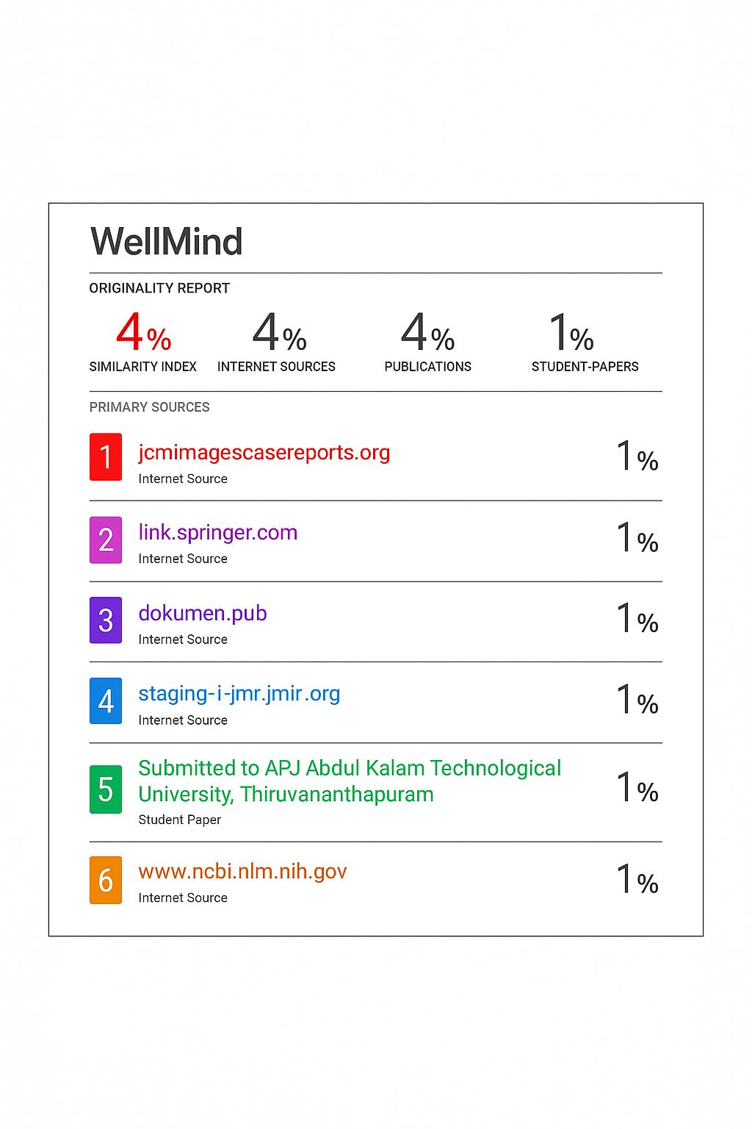

**Project Review Sheet :**

**Review 1 :**

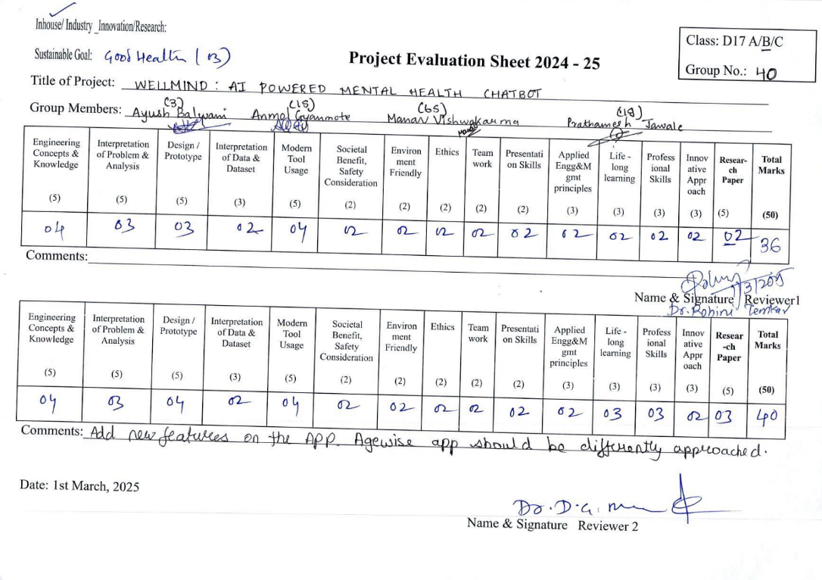

**Review 2 :-**

